Craftstick Bridge

Subject: Science, Mathematics  Related Subjects: Civil Engineering | Grade Level(s): All grades  Length of Lesson: 2-3 hours | Type: Project  Keywords: Bridges, Load-bearing, Velcro joints, Craft sticks, Model construction

Lesson Overview
Students will use math and Science to implement engineering concepts in the design and construction of a model bridge from their own plans that will carry a maximum load while using as few craft sticks as possible; stressing neatness, craftsmanship, and creativity. In this activity, students will use craft sticks and Velcro to understand the principles involved and to test various designs. Pictures of different bridges have been provided at the end of this guide.

Lesson Focus
How do civil engineers optimize material use while maintaining structural strength and functionality in bridge design?

Lesson Objective(s) | - Understand the effects of geometry, tension, and compression on structures.  - Design a functional model bridge that meets real-world constraints.  - Apply mathematical reasoning and engineering concepts to a physical prototype.  - Evaluate their design through a live load-bearing test.

Lesson Timing

30 minutes | Introduction, rules, and design sketching
75 minutes | Construction phase
45 minutes | Testing and wrap-up discussion

Materials | - Only solid untreated natural wood craftsticks (e.g. popsicle sticks)  - Maximum number of sticks allowed, including partial sticks, is 50. Each piece of stick, regardless of size, will be counted as one structural member.  - Velcro must be used to attach pieces.
Instructor Prep | - Pre-cut and count materials for each group (maximum 50 craft sticks).  - Set up a clear area with a sand bucket or testing platform for the final load test.  - Prepare images or models of real bridge types for design inspiration.  - Have toy vehicles ready to test roadway clearance.

Related Resources

Lesson Plan

Introduction
- Discuss how real engineers use limited resources to build strong, functional bridges.
- Introduce key concepts: tension, compression, span, truss, and load distribution.
- Explain all rules clearly. Emphasize roadway access, structure integrity, and Velcro limitations.
- Students sketch bridge ideas on graph paper and get instructor approval before building.

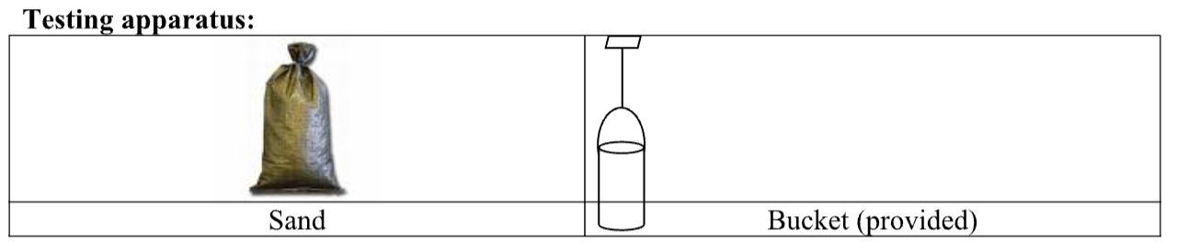

Procedure

Rules for Bridge Size:
- Maximum horizontal length 12 inches
- Maximum width 5 inches
- Maximum height above top of roadway 7 inches
- Maximum depth below top of roadway 3.5 inches
- Minimum horizontal length 10 inches
- Minimum width at every point. 4 inches
- Minimum width of open roadway 3.5 inches (running entire length of bridge)
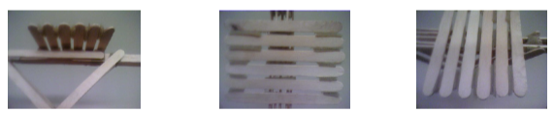

RULES FOR CONSTRUCTION:

- A maximum of 50% of a craftstick’s total flat surface may be Velcroed. Both sides of each stick can be considered in the 50% calculation. e.g. 100% of side 1 and 0% of side 2; 75% of side 1 and 25% of side 2.
- Velcro must only be used at joints, and must not be used on the surface of the roadway.
- No coatings of any kind, including glue, paint, cement, epoxy; etc. may be applied to any surface of the bridge. The Bridge will be disqualified if it is coated with any substance.
- The bridge must be open at the top to allow insertion of testing apparatus.
- Bridge must have a 1cm gap in the center to accommodate the testing apparatus (This is only for the classroom testing apparatus and will not be the case in the actual competition).
- I-beams are illegal.
- The bridge must have a clear and unobstructed roadway at least 3 ½ inches wide, running the full length of the bridge, as if automobile traffic were going to cross it. The roadway shall be considered a roadway if a toy model car or truck freely rolls from one end to the other. The toy car/truck can be provided by the entrant. If a car is not provided by the entrant, a standard “Hot Wheels” or “Matchbox” car will be used.
- The bridge may not have a roof, covering or any other object that will interfere with the 3 1⁄2 x 3 1⁄2 test plate that is placed directly on the roadway at midspan to apply the force for load bearing capacity.
- T-sections and longitudinal Velcro may be used on the roadway only.
- The bridge must rest on the tester support blocks in a stable manner, i.e. bridge substructure may NOT interfere with testing apparatus.

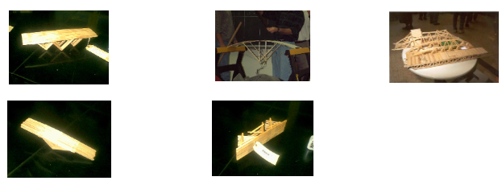

Wrap-up
What shapes helped distribute the load best? Did material use impact performance? How did teams ensure roadway access and stability? How does this model real-world engineering challenges?

Lesson Background for Teachers
This challenge mirrors real civil engineering scenarios where safety, material constraints, and function must be balanced. Students are pushed to think about geometry, force distribution, and construction efficiency while staying within real-world design limits like road clearance and material cost.

Suggested Real-World STEM Connections
- Civil Engineers who design and build infrastructure
- Bridge Designers focused on safety, performance, and cost
- Structural Analysts who test and simulate real-world load conditions

Lesson Variations and Options
- Speed Build Round: Impose a 30-minute construction deadline.
- Disaster Test Simulation: Simulate earthquakes or wind with shaking or blowing tests.
- Design Justification: Teams explain why they chose their structure and shape before testing.

Explanation
Craft stick bridges help demonstrate how forces move through a structure. Compression pushes down on materials, while tension pulls them apart. Shapes like triangles and arches resist deformation better than squares. Real bridges use similar design ideas but at larger scales and with heavier materials.

Key Concepts and Vocabulary
- Tension – Pulling force
- Compression – Squeezing force
- Span – The distance between supports
- Clearance – Open space needed under or within the bridge
- Load Distribution – How weight is spread through the structure

Safety Notes
- Supervise cutting tools and use of Velcro adhesives.
- Keep hands and faces clear of load-testing areas.

